**JIIT CAFE ONLINE ORDERING WEBSITE**

*Project Report*

*Database System and Web Lab*

*15B17CI372*



JAYPEE INSTITUTE OF INFORMATION TECHNOLOGY

(Declared Deemed to be University U/S 3 of UGC Act)

A-10, SECTOR-62, NOIDA, INDIA

November,2023

**Submitted to: Ms. Dhanalakshmi**

**Submitted by: B-11 batch**

**Satvik Pandey 22103324**

**Simran Sardana 22103342**

**Pratham Pandey 22103335**

**TABLE OF CONTENTS**

|  |  |  |
| --- | --- | --- |
| **S.No** | **DESCRIPTION** | **PAGE No.** |
| 1 | MAIN AIM | 3 |
| 2 | ABOUT | 3 |
| 3 | OBJECTIVE | 4 |
| 4 | FLOWCHART | 5 |
| 5 | WEBSITE | 6 |
| 6 | FUTURE SCOPE | 14 |
| 7 | REFERENCES | 16 |

**MAIN AIM**

To make an online ordering website for the college students as well as the faculty of JIIT-Sec62.

**ABOUT**

Thie website will allow the students or faculty of Jaypee Institute of Information Technology to order from our website from anywhere whether it is from the cafeteria itself or from JBS or ABB-I.

The site will specifically display the menu for the day, the items available, the ones that have finished as well as the special of the day.

To ensure that the orders are only placed by the students or the faculty of the institution, the users have to login using their login ids of web-portal provided by the college itself.

At first, when the website would load we expect to see a login page. It further proceeds to take the information on whether the order has been successfully placed. We would be re-directed to the home page and them we would be able to see the items ordered by us by accessing the profile, further the order details with its attributes.

**OBJECTIVE**

* Efficient Ordering System:

Provide an easy-to-use and intuitive online platform for ordering food and other items.

Streamline the ordering process to ensure efficiency and quick transactions.

* User-Friendly Interface:

Design a user-friendly interface accessible to both college students and faculty members.

Implement a responsive design that works seamlessly on various devices (desktops, laptops, tablets, and mobile phones).

* Customized User Accounts:

Allow users (students and faculty) to create individual accounts for personalized experiences.

Enable users to save their order history, preferences for a convenient ordering process.

* Menu Variety and Customization:

Offer a diverse and inclusive menu catering to different dietary preferences and requirements.Allow users to customize their orders, add special instructions, and choose from various food categories.

By addressing these objectives, the online ordering website aims to create a seamless, user-centric experience for the institution, fostering convenience, engagement, and satisfaction.

The main agenda of this project is to make ordering convenient in the cafe rather than having to stand in the queue. However, that would definitely still be an option. The reason it would definitely not cause any difficulties in the payment also is because as we all know that the café has no system of accepting cash. Moreover, it would work just as perfectly as any other ordering site that either takes payment via the credit/debit cards or UPI.

**FLOWCHART**

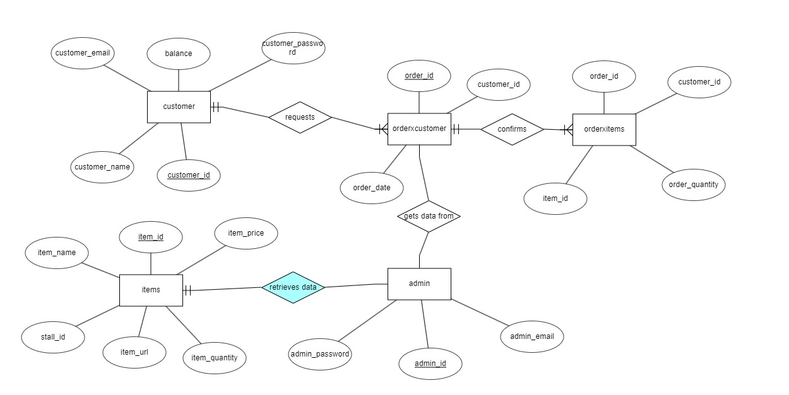

**WEBSITE**

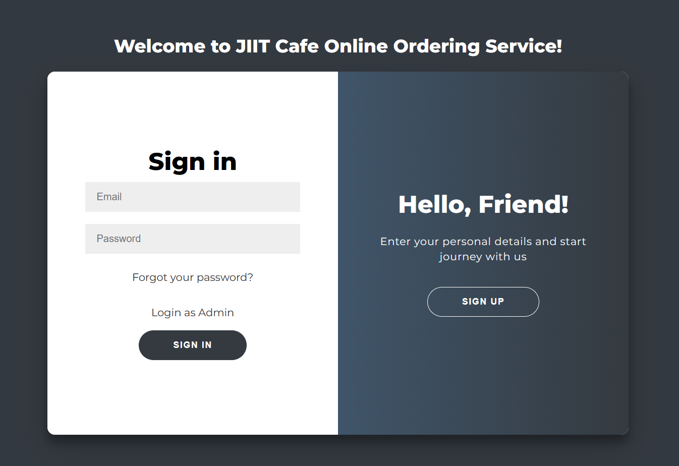

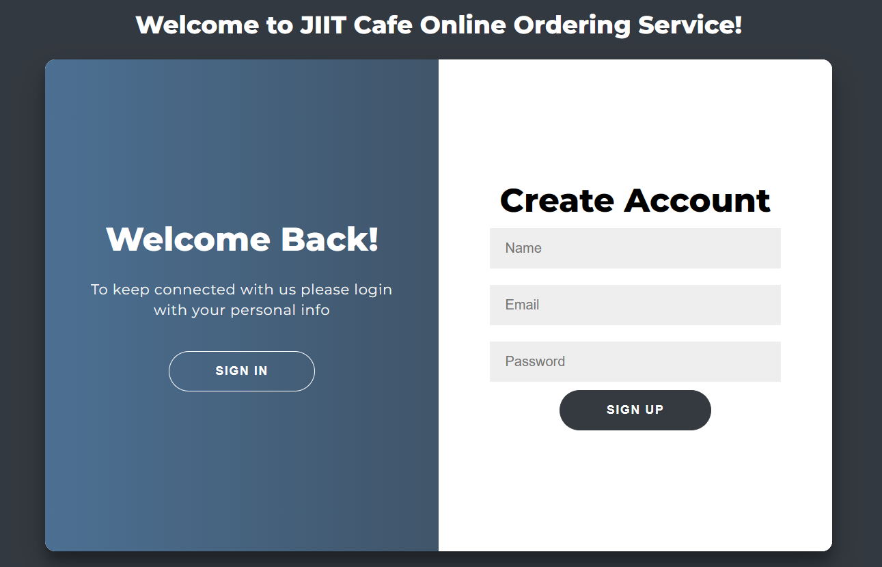

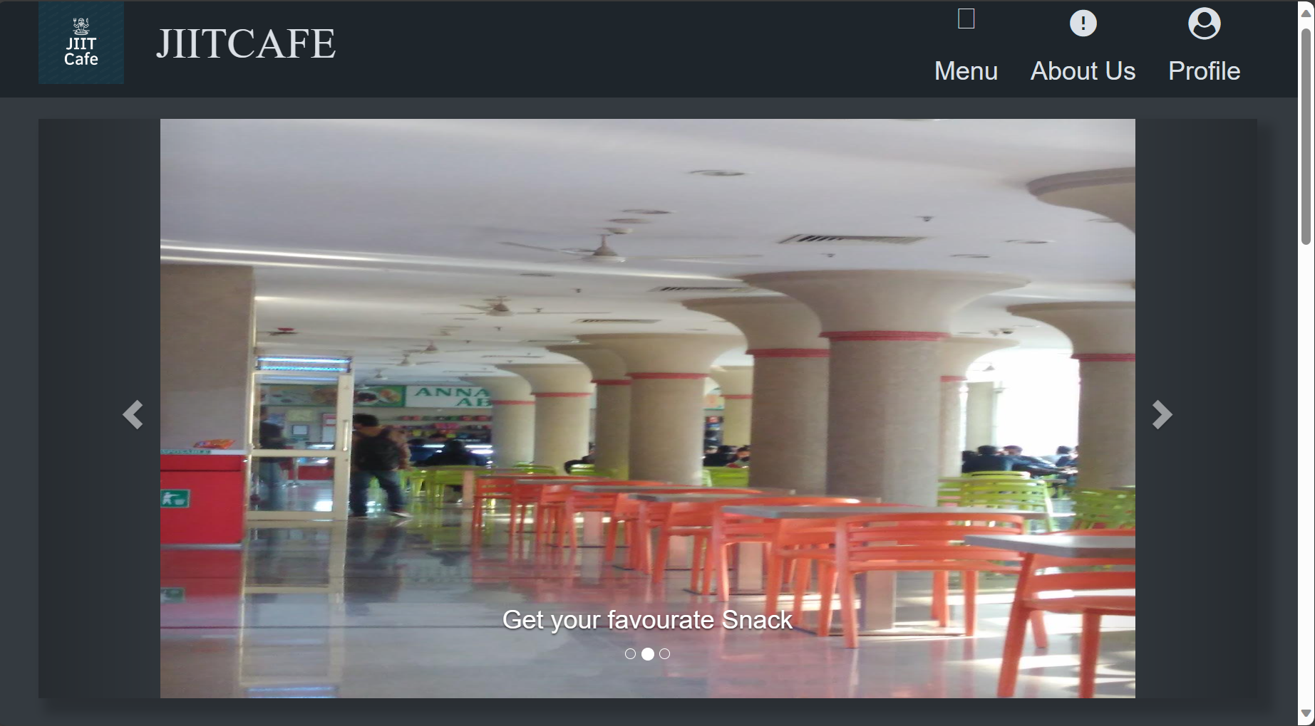

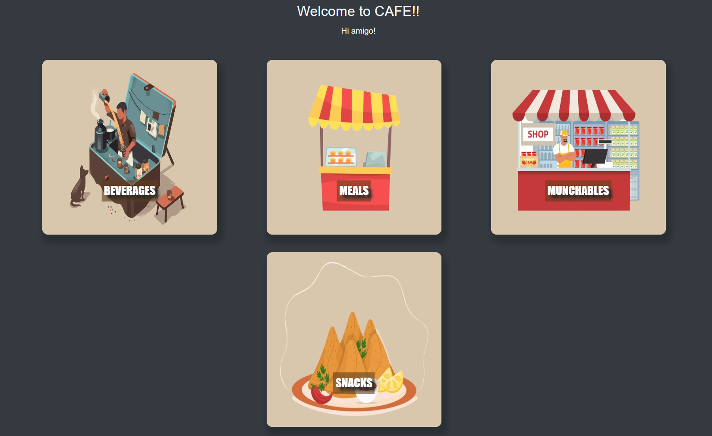

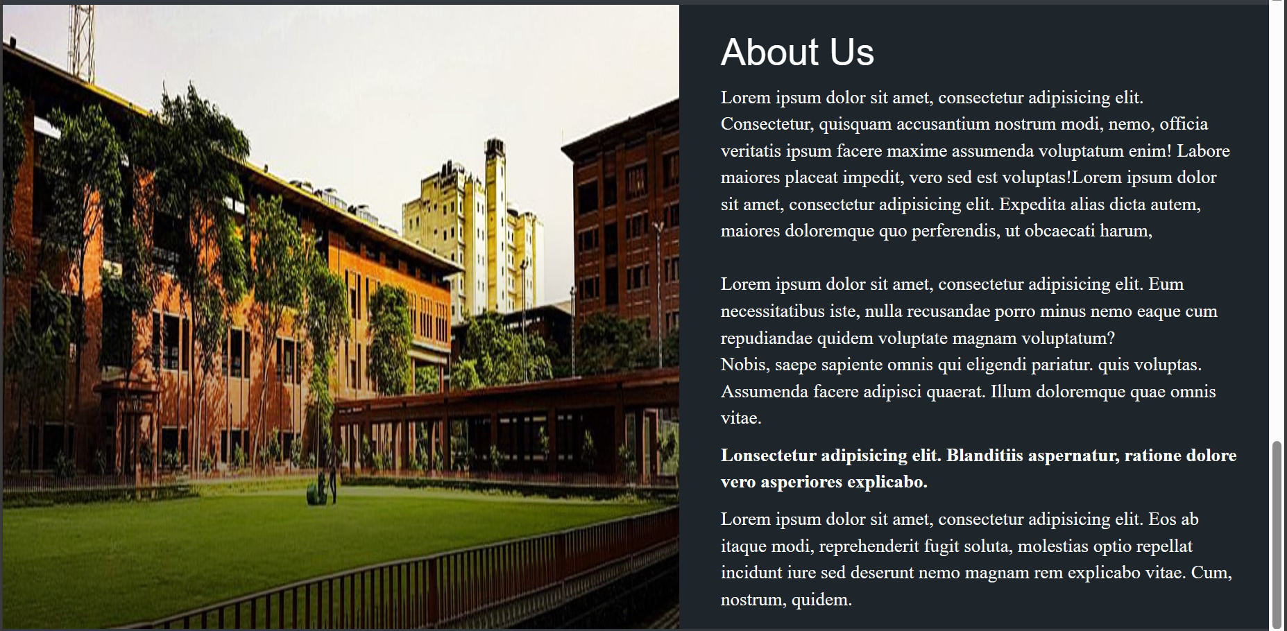



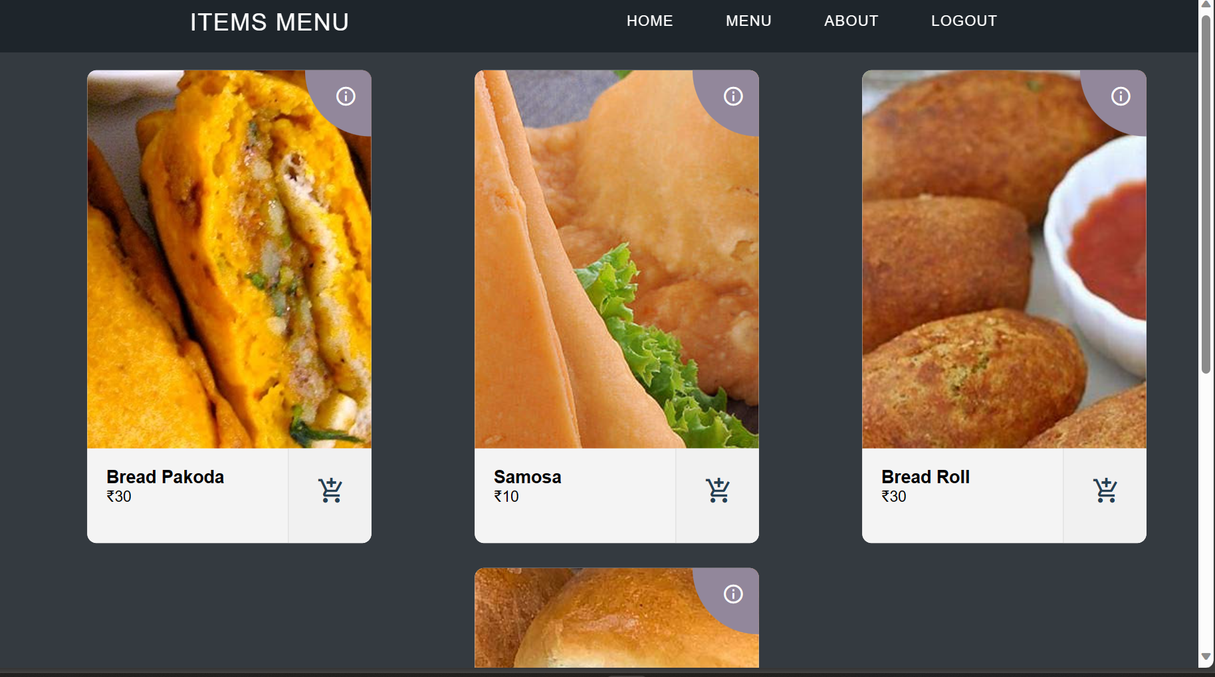

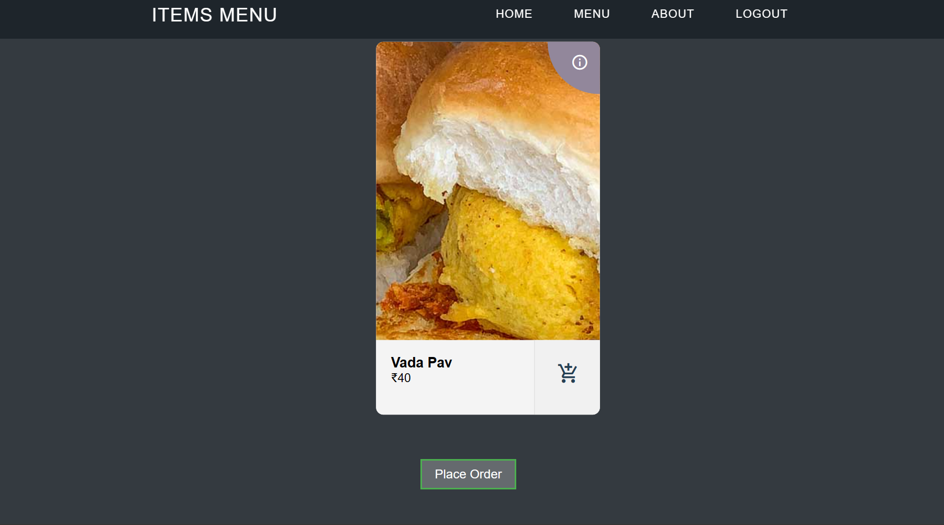

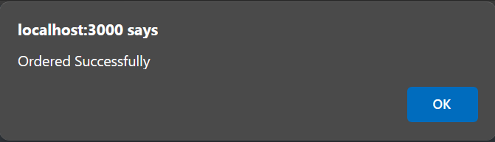

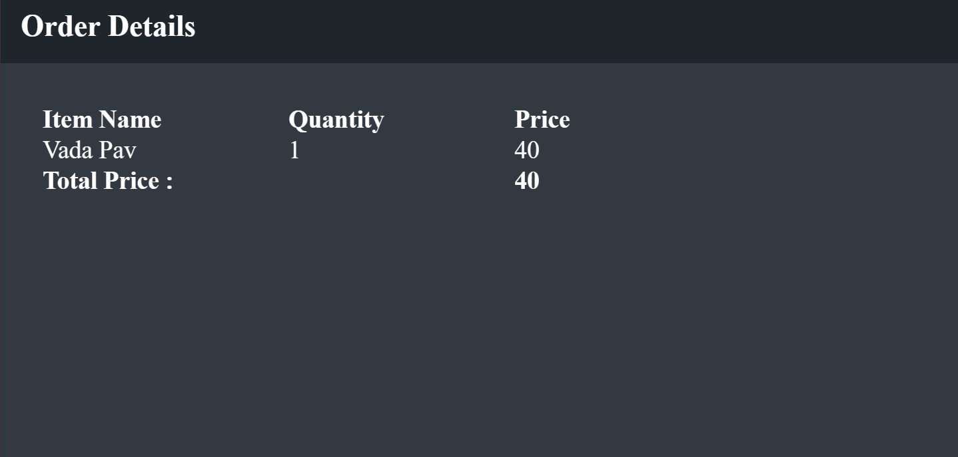

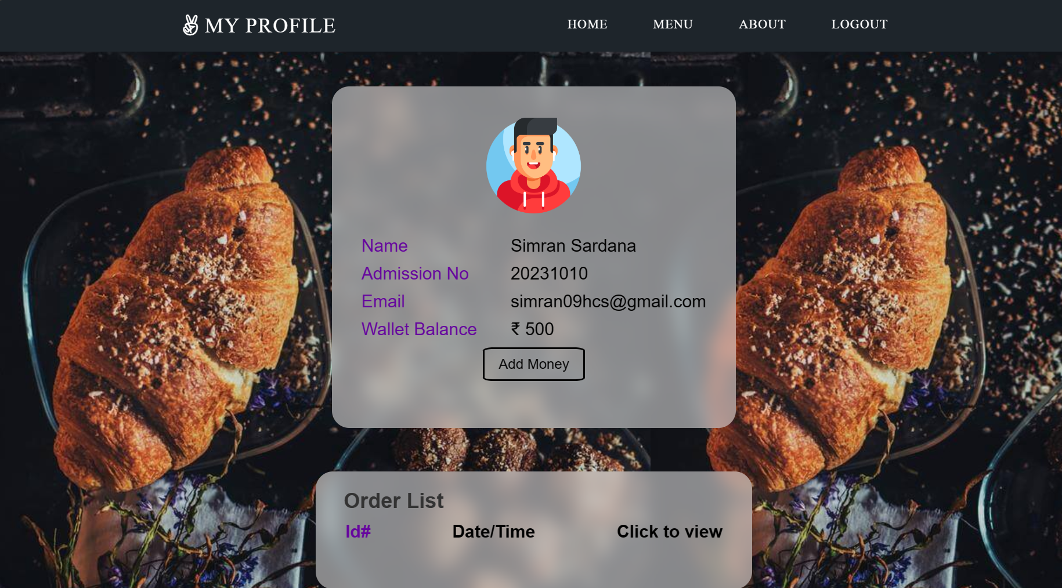

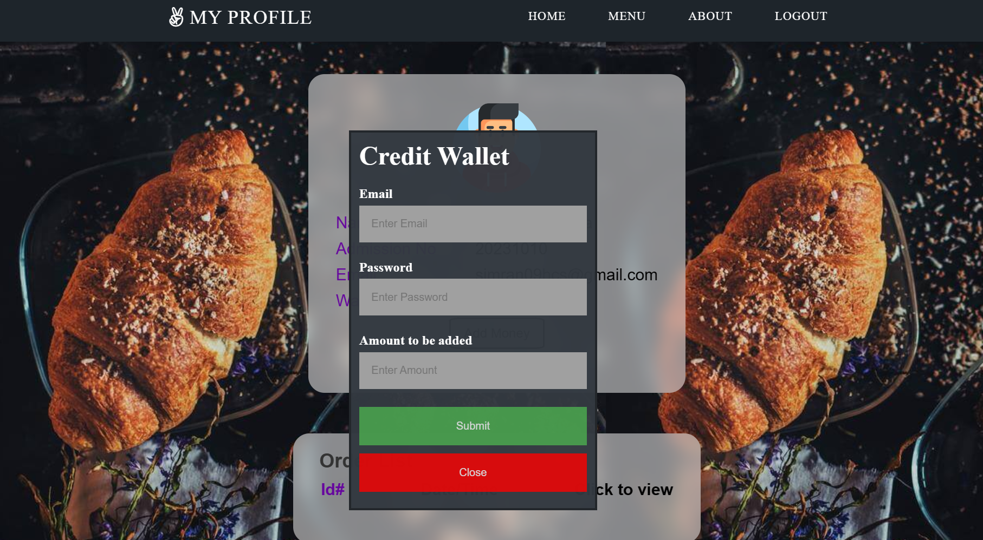

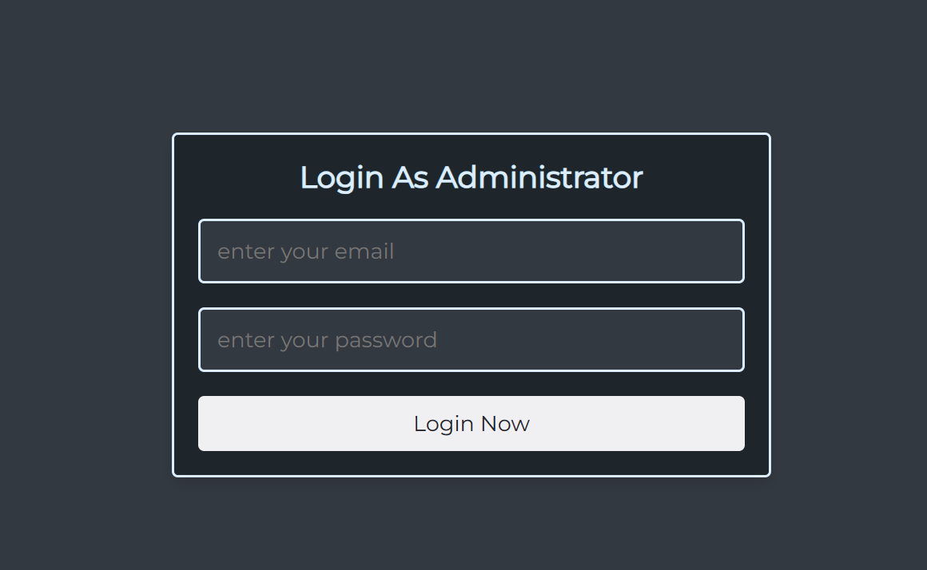

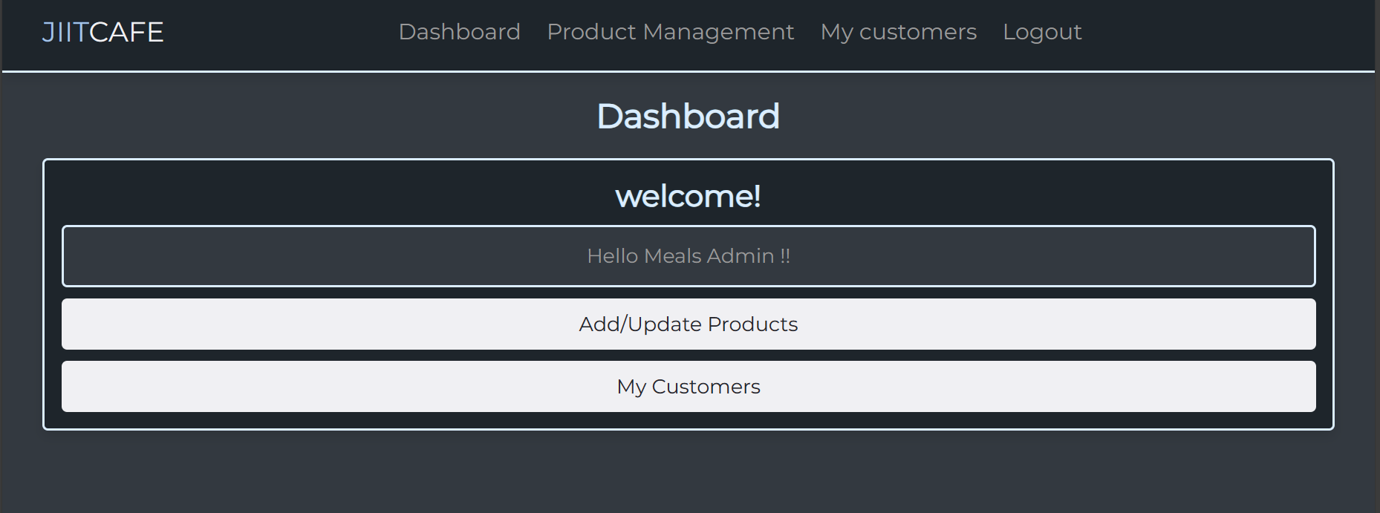

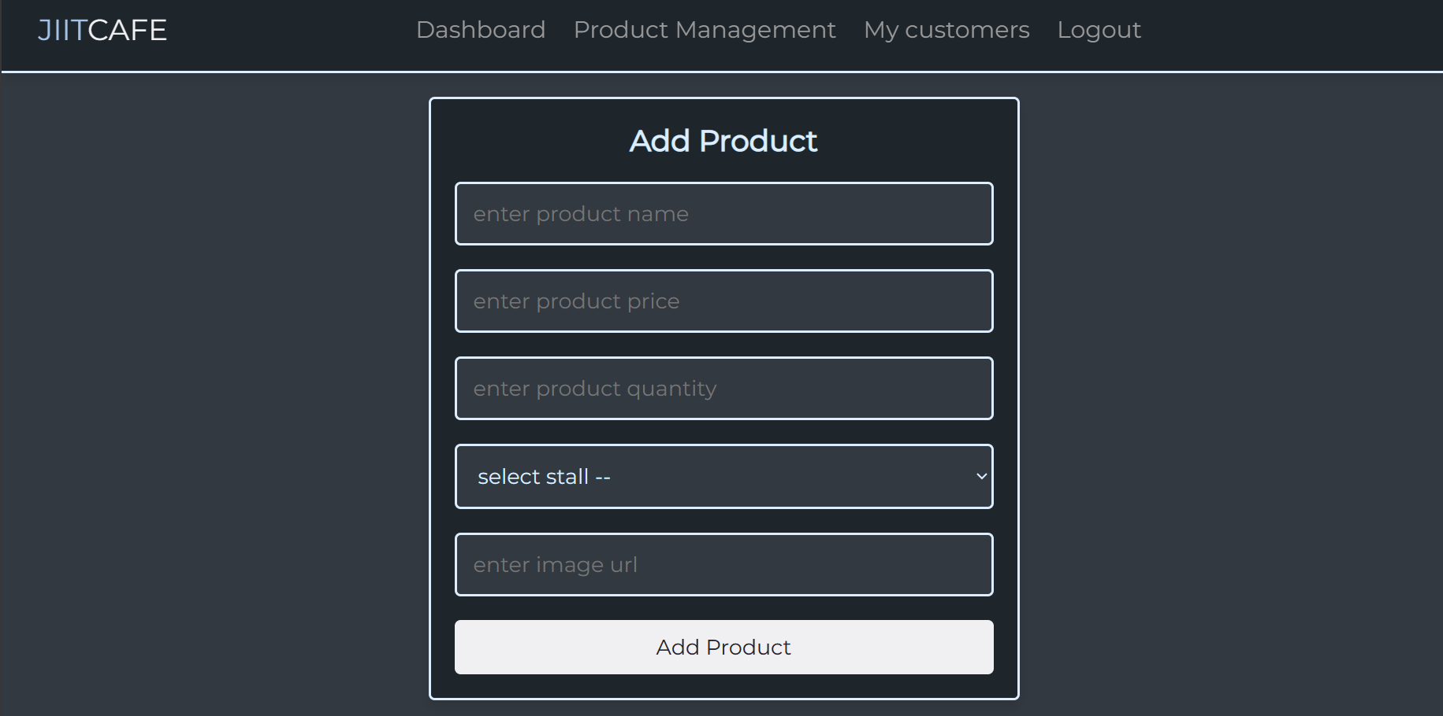

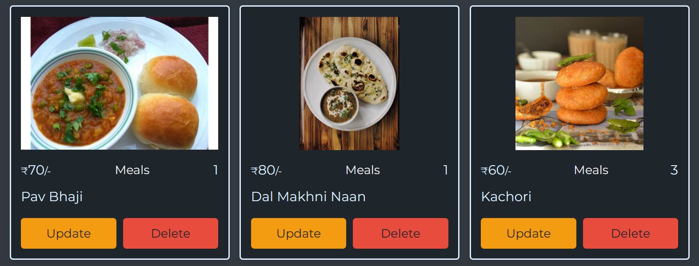

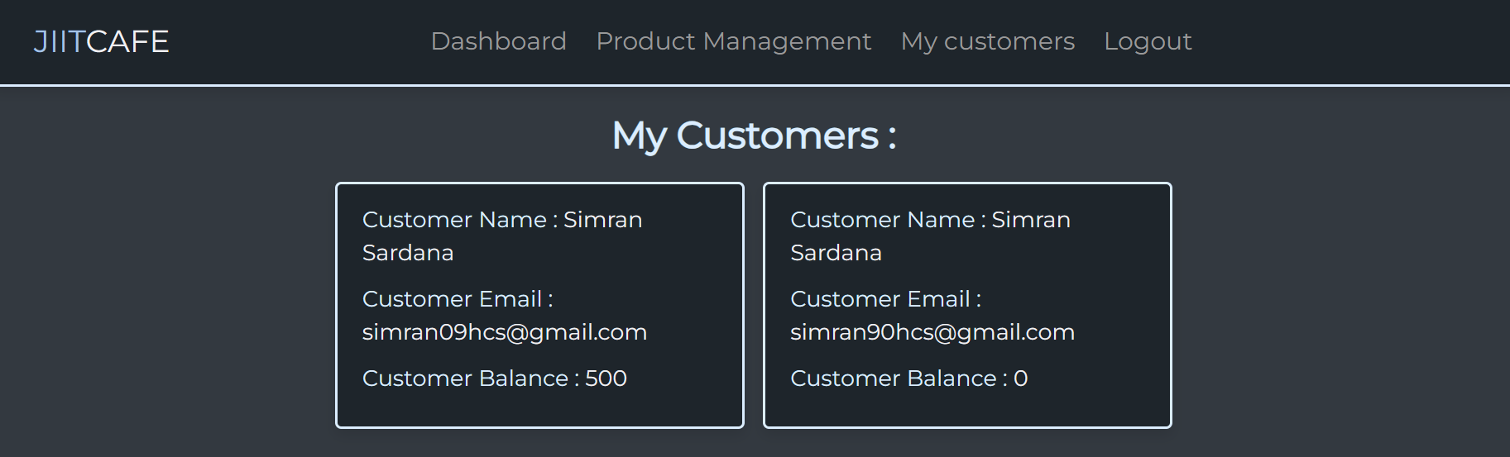

**FUTURE SCOPE**

The future scope of the Online Ordering Platform for JIIT-Sec62 can be expanded and enhanced in various ways to meet the evolving needs of the users and keep up with technological advancements. Here are some potential areas for future development:

* Mobile Application Development:

Consider developing a mobile application for both Android and iOS platforms. A dedicated mobile app can provide users with more features, push notifications, and an even more seamless on-the-go ordering experience.

* Integration of AI and Chatbots:

Implement artificial intelligence (AI) and chatbot technology to enhance user interactions. A chatbot can assist users in placing orders, provide recommendations, and address common queries, improving overall customer service.

* Advanced Personalization:

Enhance the personalization features by utilizing machine learning algorithms. Analyze user preferences, order history, and behavior to offer tailored recommendations and promotions, creating a highly personalized user experience.

* Expanded Delivery Options:

Explore partnerships with local delivery services or implement your own delivery system. Provide users with flexible delivery options, such as scheduled deliveries, express deliveries, or pick-up points on the campus.

* Blockchain for Transparency:

Consider integrating blockchain technology to enhance transparency in the supply chain. This can provide users with detailed information about the origin of the food products, promoting trust and sustainability.

* Multi-Language Support:

Expand language options to cater to a more diverse audience. Implementing multi-language support can enhance inclusivity and make the platform accessible to users from various linguistic backgrounds.

* Integration with Campus Events:

Strengthen the integration with campus events and activities. Collaborate with event organizers to offer special promotions during events, creating synergy between the platform and the vibrant campus life.

* Virtual Food Tasting and Augmented Reality (AR):

Introduce virtual food tasting experiences through AR. Allow users to virtually experience the appearance and taste of different menu items before placing an order, enhancing the online food exploration process.

* Enhanced Loyalty Programs:

Evolve the loyalty programs by introducing tiered memberships, exclusive perks, and partnerships with other local businesses. This can further incentivize user loyalty and engagement.

* Data Analytics for Business Insights:

Utilize advanced data analytics tools to gain insights into user behavior, popular items, and peak ordering times. This data can inform marketing strategies, inventory management, and overall business decisions.

Continuous innovation and adaptation to emerging technologies will be crucial for the long-term success and sustainability of the Online Ordering Platform for JIIT-Sec62. Regular feedback from users and staying informed about industry trends will help shape the platform's future developments.

**REFERENCES**

* Youtube videos
* Lecture Notes
* Github